INDIAN SCHOOL AL WADI AL KABIR
Chapter 5 (Book 2)- Change and Development in Industrial Society (GRADE XII)
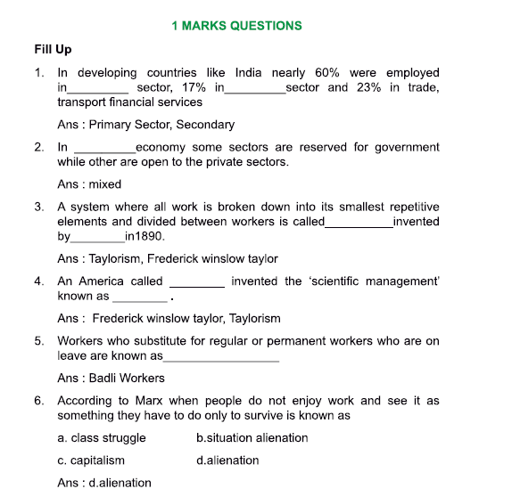
Question Bank
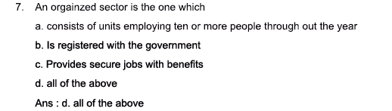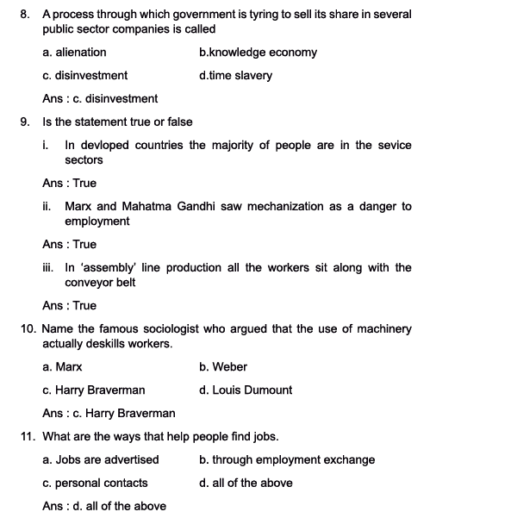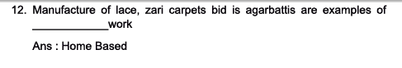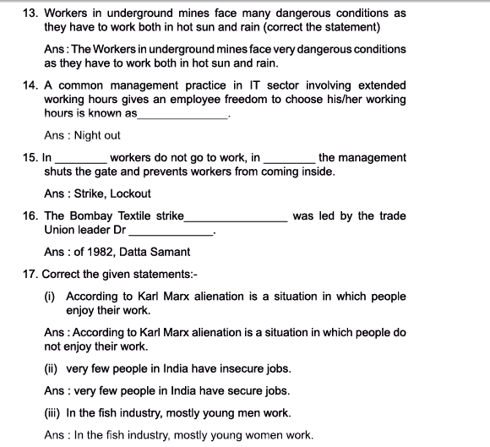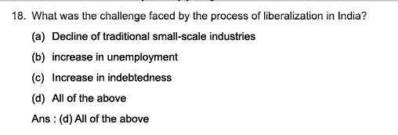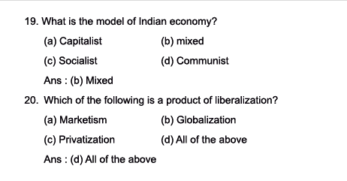
2-mark Questions:
- What is industrialization? Ans: Industrialization is a process whereby production is done on a large scale through large machines. Modern technology is used under industrialization through which man becomes dependent on machines, and as a result of this production is increased. Industrialization is characterized by urbanization, loss of face-to-face relationships and involves division of labour.
- Differentiate between developed and developing countries? Ans: In developed countries, the majority of people are in the service sectors, followed by industry and less than 10% are in agriculture. In developing countries like India, nearly 60% are employed in the primary sector (agriculture and mining), 17% in the secondary sector (manufacturing, construction and utilities), and 23% in the tertiary sector (trade, transport, financial services etc).
- What is ‘mixed economy’? Ans: A mixed economic system is a system that combines aspects of both capitalism and socialism. A mixed economic system protects private property and allows a level of economic freedom in the use of capital, but also allows for governments to interfere in economic activities in order to achieve social aims.
- What is disinvestment? Ans: Disinvestment means sale or liquidation of assets by the government, usually Central and state public sector enterprises, projects, or other fixed assets.
- List the two demands of the Bombay Textiles workers’ strike of 1982. Ans: The Bombay Textile Strike of 1982 which was led by trade union leader Dr. Datta Samant and nearly affected a quarter of million workers fought for better wages and they also wanted the right to form their own union.
- How do people find jobs? Ans: People find jobs in the following ways: advertisements (Times Ascent), through employment exchange, through personal contacts (self-employed plumbers, tutors etc) and through contractors and jobbers/mistris (Kanpur)
- Who are badli workers? Ans: Badli workers substitute for regular permanent workers who are on leave. Many of the badli workers are not given the same status and security. This is what is called contract work in the organized sector.
- What is ‘home based work’? Why is it an essential part of the economy? Ans: Home-based work is an important part of the economy. This includes the manufacture of lace, zari or brocade, carpets, bidis, agarbattis and many such products. This work is mainly done by women and children. An agent provides raw materials and also picks up the finished product. Home workers are paid on a piece- rate basis depending on the number of pieces they make.
- Differentiate between strikes and lock outs. Ans: In response to harsh working conditions, sometimes workers went on strike, in a strike, workers do not go to work, in a lock-out the management shuts the gate and prevents workers from coming. To call a strike is a difficult decision as managers may try to use substitute labour. Workers also find it hard to sustain themselves without wages.
- What are the basic tasks of the manager? How can he make the worker produce more? Ans: The basic task of a manager is to control workers and get more work out of them. The following are the ways of making workers produce more:
-extend the working hours
-increase the amount to be produced within a given time period
- organizing work
Production is speeded up through ‘scientific managemet’ and ‘assembly line’

4 marks Questions:
- What are the social implications/advantages of the organized sectors?
Ans: Economists and others often make a distiction between the organized or formal sector and the unorganized or informal sector. There is a debate about how to define these sectors. According to one definition, the organized sector consists of all units employing ten or more people throughout the year. These have to be registered with the government to ensure that their employees get proper salaries or wages, pension and other benefits. In India, over 90% of the work, whether it is in agriculture, industry or services is in the unorganized or informal sector. The social implications of this are as follows:
- First, it means that very few people have the experience of employment in large firms where they get to meet people from other regions and backgrounds. Urban settings do provide some corrective to this- your neighbours in a city may be from a different place- but by and large, work for most Indians is still in small scale workspaces.
- Second, very few Indians have access to secure jobs with benefits. Of those who do, two- thirds work for the government. The rest are forced to depend on their children in their old age.
- Third, since very few people are members of unions, a feature of the organized sector, they do not have the experience of collectively fighting for proper wages and sage working conditions. The government has laws to monitor conditions in the unorganized sector, but in practice they are left to the whims and fancies of the employer or contractor
- ‘The more mechanized an industry gets, the fewer people are employed’. Justify the statement with a suitable example.
Ans: While machinery helps to increase production, it also creates the danger of humans being eventually being replaced by machines. Both Marx and Mahatama Gandhi saw mechanization as a danger to employment.
The more mechanized an industry gets, the fewer people are emplyed, and they too have to work at the pace of the machine. Take the example of Maruti Udyog Ltd. Where two cars roll off the assembly line every minute. Workers get only 45mins test in the entire day- two tea breaks of 7.5 mins each and one lunch break of half an hour. Most of them are exhausted by the age of 40 and take voluntary retirement.
While production has gone up, the number of permanent jobs in the factory has gone down. The firm has outsourced all services like cleaning, and security, as well as the manufacture of spare parts. The parts suppliers are located around the factory and send the parts every two hours or just-in-time. Outsourcing and just-in-time keeps costs low for the company, but the workers are very tense, because if the supplies fail to arrive, their production targets get delayed, and when they do arrive they have to run to keep up.
- Explain the concept of industrial engineering/scientific management/Taylorism.
Ans: One way of increasing output is by organizing work. An Amercian called Frederick Winslow Taylor invented a new system in the 1890’s, which he called ‘Scientific Manangement’. It is also known as Taylorism or industrial engineering.
Under his system, all work was broken down into its smallest repititive elements, and divided between workers. Workers were timed with the help of stopwatches and had to fulfil a certain target everyday. Production was further speeded up by the introduction of the assembly line.
Each worker saw along a conveyor belt and assembled only one part of the final product. The speed of work could be set by adjusting the speed of the conveyor belt. In the 1980’s, there was an attempt to shift from this system of direct control to indirect control, where workers are supposed to motivate themselves. But often we find that the old Taylorist processes survive.
- How does job recruitment take place through the ‘contractor system’?
Ans: The contractor system is most visible in the hiring of casual labour for work on construction sites, brickyards and so on. The contractor goes to villages and asks if people want to work. He will loan them some money. This loan includes the cost of transport of the worksite. The loaned money is treated as an advance wage and the worker works without wages until the loan is repaid.
In the past, agricultural labourers were tied to their landlord by debt. Now, however, by moving to casual industrial work, while they are still in debt, they are not bound by other social obligations to the contractor. In that sense, they are freer in an industrial society. They can break the contract and find another employer. Sometimes, whole families migrate and the children help their parents.
- Examine the working conditions of the mine workers.
Ans: The Mines Act of 1952 specifies the maximum number of hours a person can be made to work in a week, te need to pay overtime for any extra hourns worked and safety rules. These rules may be followed in the the big companies, but not in smaller mines and quarries.
Coal mines alone employ 5.5 lakh workers. Sub- contracting is widespread in this sector. Many contractors maintain proper registers of workers, thus avoiding any responsibility for accidents and benefits.
After mining has finished in an area, the company is supposed to cover up the open holes and restore to its earlier condition. But they don’t do this.
Workers in underground mines face very dangerous conditions, due to flowing, fire, the collapse of roofs and sides, the emission of gases and ventilation failures.
Many workers have developed breathing problems and diseases like tuberculosis and silicosis. Those working in overground mines have to work in both hot sun and rain, and face injuries due to mine blasting, falling objects etc. The rate of mining accidents in India is very high compared to other countries.

- Explain home based work with the help of an example.
Ans: Home-based work is an important part of the economy. This includes the manufacture of lace, zari or brocade, carpets, bidis, agarbattis and man such products. This work is mainly done by women and children. An agent provides raw materials and also picks up the finished product. Home workers are paid on a piece-rate basis, depending on the number of pieces they make.
We can take the example of the bidi industry. The process of making bidis starts in forested villages where villagers pluck tendu leaves and week it to the forest department or a private contractor who in turn sells it to the forest department. On average a person can collect 100 bundles (of 50 leaves each) a day. The government then auctions the leaves to bidi factory owners who give it to the contractors. The contractor in turn supplies tobacco and leaves to home-based workers.
These workers, mostly women, roll the bidis- first dampening the leaves, then cutting them, filling in tobacco evenly and then tying them with thread. The contractor picks up these bidis and sells them to the manufacturer who roasts them, and puts on his own brand label. The manufacturer then sells them to a distributor who distributes the packed bidis to wholesalers who in turn sell them to the neighbourhood pan shops.
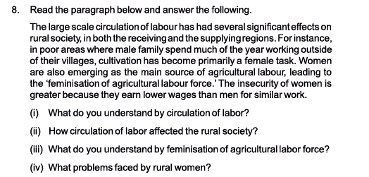

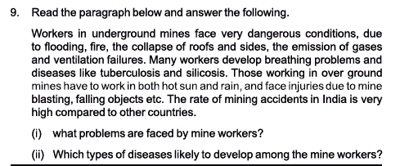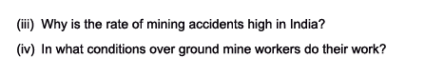
6 marks Questions:
- Discuss the changes brought about in the Indian industry due to the impact of globalization and liberalization.
Ans: In India’s mixed economy policy, where some sectors were reserved for government, while others were open to the private sector. But within that, the government tried to ensure, through its licensing policy, that industries were spread over different regions.

Before independence, industries were located mainly in the port cities like Madras, Bombay, Calcutta. But since then, we see that place like Baroda, Coimbatore, Bangalore, Pune, Faridabad and Rajkot have become important industrial centres.

The government also tried to encourage the small-scale sector through special incentives and assistance. Many items like paper and wood products, stationery, glass and ceramics were reserved for the small-scale sector. In 1991, large-scale industry employed only 28 per cent of the total workforce engaged in manufacture, while the small-scale and traditional industry employed 72 per cent.

Since the 1990s, however, the government has followed a policy of liberalization. Private companies, especially foreign firms, are encouraged to invest in sectors earlier reserved for the government, including telecom, civil aviation, power etc. Licenses are no longer required to open industries. Foreign products are now easily available in Indian shops.

As a result of liberalization, many Indian companies have been bought over by multinationals. At the same time some Indian companies are becoming multinational companies. An instance of the
first is when, Parle drinks was bought by Coca Cola. Parle’s annual turnover was Rs. 250 crores, while Coca Cola’s advertising budget alone was Rs. 400 crores. This level of advertising has naturally increased the consumption of coke across India replacing many traditional drinks. The next major impact of liberalization was in the retail industry.

- How has liberalization affected employment patterns in India?
Ans: Due to the disinvestment process (where the government is trying to sell its share in several public sector companies), many government workers are scared that they will lost their jobs.
In Modern foods which was set up the government to make healthy bread available at cheap prices, and which was the first company to be privatised, 60% of the workers were forced to retire in the first five years.
This is just one among the many examples of how liberalization has effected employment patterns in India. Some other impacts are as follows:
- Companies reducing the number of permanent employees and outsourcin their work to smaller companies or even to homes
- For multinational companies this outsourcing is done across the globe, with developing countries like India providing cheap labour.
- Because small companies have to compete for orders from the big companies, they keep wages low, and working condition sare often poor.
- It is more difficult for trade unions to organize in smaller firms. Almost all companies, even government ones, now practice some form of outsourcing and contracting. But the trend is especially visible in the private sector.
To summarize, India is still largely an agricultural country. The servic sector- shops, banks, the IT industry, hotels and other services are employing more people and the urban middle class is growing, along with the urban middle class values like those we see in television serials and films. So far, employment employment by the government was a major avenue for increasing the well-bring of the population, but now even that is coming down. Some economists debate this, but liberalization and privatization worldwide appear to be associated with rising income inequality.

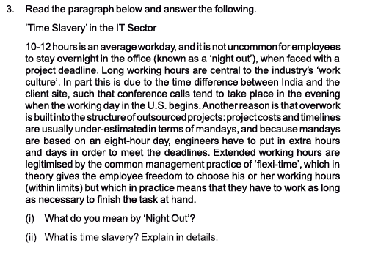
Textbook Questions:
1.Choose any occupation you see around you – and describe it along the following lines (a) social composition of the work force – caste, gender, age, region (b) labour process – how the work takes place, (c) wages and other benefits, (d) working conditions – safety, rest times, working hours, etc.
Ans. 1. Since 1990’s, the government has followed policy of liberalization. Private companies, especially foreign firms encouraged investment in sector which was earlier reserved for the government.
2. Generally, people get jobs through advertisement or through employment exchange in industrial sector. Man and women both work in industrial sector. The persons engaged in industry get salary or wages along with certain benefits like HRA (House Rent Allowance) and medical facilities.
3. Job recruitment as a factory worker takes a different pattern. In the past, many workers got their jobs through contractors or jobbers. In the Kanpur textile mills, these jobbers were known as mistris, and were themselves workers. They came from the same regions and communities as the workers, but because they had the owner’s backing they bossed over the workers.
4. The mistri also put community related pressures on the workers. Nowadays, the importance of the jobber has come down, and both management and unions play a role in recruiting their own people.
5. Workers also expect that they can pass on their jobs to their children. Many factories employ badli workers who substitute for regular permanent workers who are on leave. Many of these badli workers have actually worked for many years for the same company but are not given the same status and security. This is what is called contract work in the organized sector.
6. The contractor system is most visible in the hiring of casual labour for work on construction sites, brickyards and so on. The contractor goes to villages and asks if people want work. He will loan them some money. This loan includes the cost of transport of the work side.
7. The loaned money is treated as an advance wage and the worker works without wages until the loan is repaid. In the past, agricultural labourers were tied to their landlord by debt. Now, however, by moving to casual industrial work, while they are still in debt, they are not bound by other social obligations to the contractor. In that sense, they are freer in an industrial society. They can break the contract and find another employer. Sometimes, whole families migrate and the children help their parents.
8. Presently social composition of the work force in industry is concerned, people from all caste and both gender from the age group of fifteen to sixty work. Some regions of the country are having more industry than the other.
9. Different workers have different working period in different industries according to their qualification, experience, age and risk of the job. The contract labourers get fixed amount as per the terms and conditions of contract. In organized sector, pay and allowances are better than the unorganized sector.
10.The government has passed number of rules to regulate working conditions. The Mines Act 1952 specifies the maximum number of hours a person can be made to work in a week, they need to pay overtime for any extra hours worked and safety rules. These rules may be followed in the big companies, but not in smaller mines ‘ and quarries. Moreover, sub-contracting is widespread.
11.Workers in underground mines face very dangerous conditions, due to flooding, fire, the collapse of roofs and sides, the emission of gases and ventilation failures. Many workers develop breathing problems and diseases like tuberculosis and silicosis.
2.In the account of brick making, bidi rolling, software engineers or mines that are described in the boxes, describe the social composition of the workers. What are the working conditions and facilities available? How do girls like Madhu feel about their work?
Ans. •Social institution like caste, kinship, networks, gender and regions also influence the way the work is organized or the way in which products are marketed.
•In certain jobs and departments we find more women working than the men. For example, they are working more in numbers in nursing or teaching jobs than in other sectors like engineering.
•In India, over 90% of the work, whether it is in agriculture, industry or services is in the unorganized or informal sector.
•Very few people have the experience of employment in large firms where they get to meet people from other regions and backgrounds.
•Urban settings do provide some corrective to this your neighbours in a city may be from a different place – by and large, work for most Indians is still in small-scale workplaces.
•Nearly 60% were employed in the primary sector (agriculture and mining), 17% in the secondary sector (manufacturing, construction and utilities), and 23% in the tertiary sector (trade, transport, financial services, etc.).
•The share of agriculture has declined sharply, and services contribute approximately half. This is a very serious situation because it means that the sector where the maximum people are employed is not able to generate much income for them.
•India is still largely an agricultural country. The service sector – shops, banks, the IT industry, hotels and other services are employing more people and the urban middle class is growing, along with urban middle class values like those we see in television serials and films.
•But we also see that very few people in India have access to secure jobs, with even the small number in regular salaried employment becoming more insecure due to the rise in contract labour.
•Employment by the government was a major avenue for increasing the well-being of the population, but now even that is coming down.
•Girls like Madhu enjoy their work of rolling of bidis and filling of tobacco rolled tendu leaves.
•They get opportunity to sit close to their family members and other women and listen to their chat. They spend most of their time in work in factory of bidis.
•Due to long hours of sitting in the same posture daily, they suffer from backache. Madhu wants to restart her schooling.
3. How has liberalisation attacked employment patterns in India?
Ans. •Due to liberalization foreign products are now easily available in Indian markets and shops. Due to this some of the labour have to loose their employment and jobs.
•Many Indian companies have been taken over by multinationals. At the same time some Indian companies are becoming multinational companies. An instance of the first is when, Parle drinks was bought by Coca Cola. ‘
•The next major area of liberalization may be in retail. Due to coming of foreign companies and big business. Indian houses very small traders, shopkeepers, handicraft sellers. And hawkers have lost their jobs of employment or their small business is adversely affected by big mall, showroom or Reliance, Subhiksha, etc.
•The world’s largest chains, including Wal-Mart Stores, Carrefour and TESCO, are seeking the best way to enter the country, despite a government ban on foreign direct investment in the market.
•Wal-Mart, Carrefour and TESCO to set up a retailing joint venture …India’s retail sector is attractive not only because of its fast growth, but because family-run street comer stores have 97% of the nation’s business. But this industry trait is precisely why the government makes it hard for foreigners to enter the market.
•The government is trying to sell its share in several public sector companies, a process which is known as disinvestment. Many government workers are scared that after disinvestment, they will lose their jobs.
•Companies are reducing the number of permanent employees and outsourcing their work to smaller companies or even to homes. For multinational companies, this outsourcing is done across the globe, with developing countries like India providing cheap labour. It is more difficult for trade unions to organize in smaller firms.

